Golden iPods - Where Challenge by Carson Asmundson

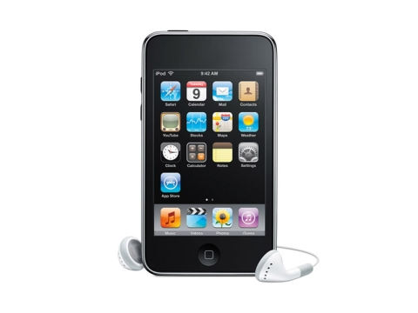
Use of gold in electronic equipment
One of the most important industrial uses of gold is in the manufacturing of electronic devices such as iPods, cell phones, MP3 players, Blackberries, calculators and Global Positioning Systems etc.

Gold is used because it is a highly efficient conductor of low voltages and currents while remaining free of corrosion. It is used in electronics as connectors, switch and relay contact, soldering, connecting wires and strips.

Gold is a non-renewable earth resource. With the increasing popularity of electronic devices, gold's value is increasing due to its limited quantity. Gold is trading at $1120/oz in February 2010.

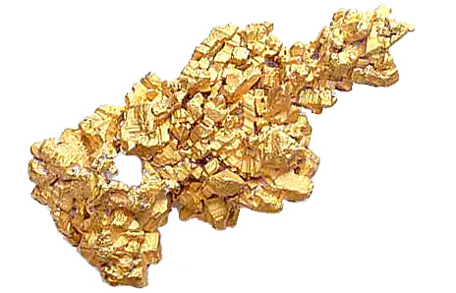

Gold in my backyard
My home is in Yellowknife and I live on gold mines (sort of). The geology of this area is known as the Yellowknife Greenstone Belt and is made of igneous rocks. Igneous rocks are formed by magma cooling and becoming solid.

Gold is formed in the underground vents of volcanoes and carried up to the surface by magma. The gold veins in Yellowknife are usually formed with quartz in the basalt and andesite rock of this area.

Gold is a chemical element with the symbol of Au and atomic number of 79. It occurs as nuggets, grains, in veins and alluvial deposits. It is dense, soft, ductile and malleable. It is highly conductive to electricity and resistant to oxidation and corrosion.

Mining for Gold in Yellowknife
The City of Yellowknife was founded as a mine supply town in 1935 after a gold discovery. There have been 11 gold mines in the Yellowknife area. The biggest mines were Con Mine and Giant Mine. Giant Mine was located just outside Yellowknife and produced 7,000,000 oz from 1984 - 2004. Con Mine was located in the City and produced 5,000,000 oz from 1938 - 2003.

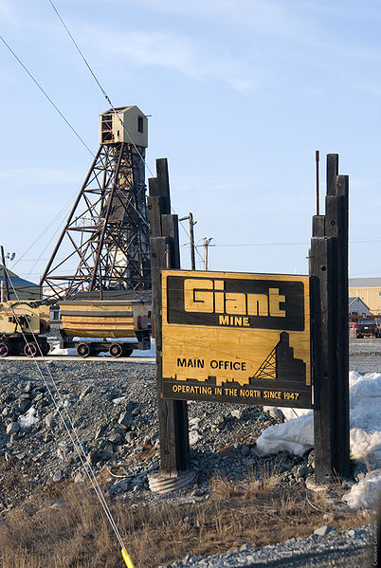
E-waste - gold goes into the trash
One of the biggest growing problems with electronics is e-waste. When consumers purchase replacements for their cell phones, computers or iPods, the majority of the electronics are not being recycled. The amount of e-waste accumulated around the world is growing by 40,000,000 tonnes every year! This means, that precious non-renewable resources like gold are being wasted. Some electronic waste is even toxic to the environment like lead.

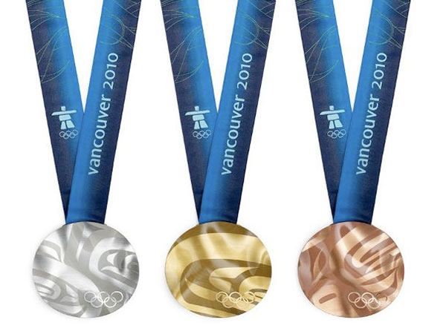
It is important for people to be aware that their electronics include gold and can be recycled. For example, the medals for the 2010 Vancouver Winter Olympic games contain gold, silver and copper waste recovered from e-waste.

